**Ginger Beer**

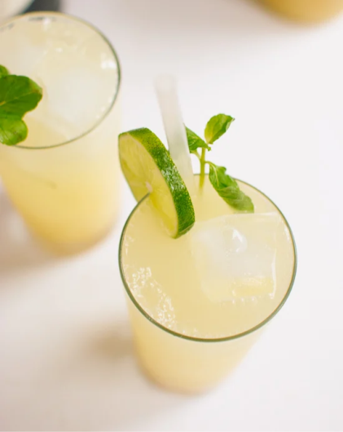

Packed full with nutrients and health benefits, this non-fizzy drink is not only delicious but really good for you!

**INGREDIENTS**

140g or about 1 cup chopped ginger

1 cup water to blend the ginger

Additional 3-4 cups water (boiled/bottled) for dilution

1 ½ cups sugar (or sweeten to taste)

1tbsp lemon juice

1tsp vanilla essence

**METHOD**

1. Thoroughly wash the ginger to remove any dirt or debris.
2. Lightly scrape the ginger with a knife to remove the brown outer skin, and roughly chop into pieces.
3. Place chopped ginger plus 1 ½ cups of water in a blender, and blend until you have a pulp consistency
4. Pour out the pulp into a large jug or container, and add in 3-4 cups of boiled water (or bottled water), and let it sit for at least 2 – 4 hours covered. The amount of water you add will depend on how strong/hot you want the ginger beer to be.
5. Strain the ginger beer after 2-4 hours, and add the lemon juice, essence, and sugar to taste. (You can also add more water if it's too strong to your taste). Stir well, until sugar is dissolved.
6. Pour over ice, and enjoy!

This recipe is my favourite, as it’s light and very refreshing. Some folks add rice, starch, or cream of tartar to their ginger beer. Do you add any of these to yours? If so, how much do you add?